SYSTEM INFORMATION MONITORING TOOL

Submitted By
SAMEER MALIK
(Regd. No. 2023-uok-03943)
JUNAID AKHTAR
(Regd. No. 2023-uok-03940)

Session 2023-2027
Submission Date: 20 Feb, 2026
Version: 2.0
University of Kotli Azad Jammu and Kashmir
Faculty of Computing & Engineering
Department of CS&IT

PROJECT REPORT SYSTEM INFORMATION MONITORING TOOL
Submitted By
SAMEER MALIK
(Regd. No. 2023-uok-03943)
JUNAID AKHTAR
(Regd. No. 2023-uok-03940)
A Report
Submitted in partial fulfillment of the requirements for the 5th semester project of
Operating system
In
Information Technology
Session 2023-2027
University of Kotli Azad Jammu and Kashmir
Faculty of Computing & Engineering

Department of CS&IT

Contents
Department of CS&IT 2
1. Project Objective 4
2. Functional Requirements 4
2.1 CPU Information 4
2.2 Memory (RAM) Information 4
2.3 Operating System Information 4
2.4 IP Address Information 4
2.5 User Interaction 4
3. Software Architecture Diagram 5
Component Diagram of the System Information Monitoring Tool 6
Module Explanations 6
* User Interface (GUI): 6
* System Info Controller: 6
* Hardware Info Provider: 6
* OS Info Provider: 6
* Network Info Provider: 6
* OS Library (psutil / platform): 6
* Operating System / Hardware Kernel: 6
5. Input & Output Requirements 7
* Input Requirements: 7
* Output Requirements: 7
6. Assumptions & Constraints 7
* Assumptions: 7
* Constraints: 7

1. Project Objective
The primary objective of this project is to design and document a robust software architecture for an Operating Systems mini-project. The system serves as a centralized utility to monitor and retrieve real-time host system specifications. It specifically solves the problem of manual data retrieval by consolidating complex hardware, software, and network information into a single, automated Graphical User Interface (GUI).

2. Functional Requirements
The system is engineered to perform the following core operations:

2.1 CPU Information
* The system shall retrieve and display the processor name.
* The system shall show the current CPU architecture.
* All CPU information shall be fetched automatically from the operating system.

2.2 Memory (RAM) Information
* The system shall display the total amount of physical RAM installed.
* The system shall retrieve memory information dynamically to reflect real-time status.
* The memory information provided shall be accurate and system-based.

2.3 Operating System Information
* The system shall identify and display the specific operating system name.
* The system shall show detailed OS version details.
* The system shall provide the system type information (e.g., 32-bit or 64-bit).

2.4 IP Address Information
* The system shall retrieve the current network IP address of the host.
* The system shall display the local network IP for user reference.

2.5 User Interaction
* The system shall provide a dedicated GUI with buttons for different information modules (CPU, RAM, OS, IP).
* Upon a button click, the respective information shall be triggered and displayed.
* The final output results shall be shown clearly on the screen.

3. Software Architecture Diagram

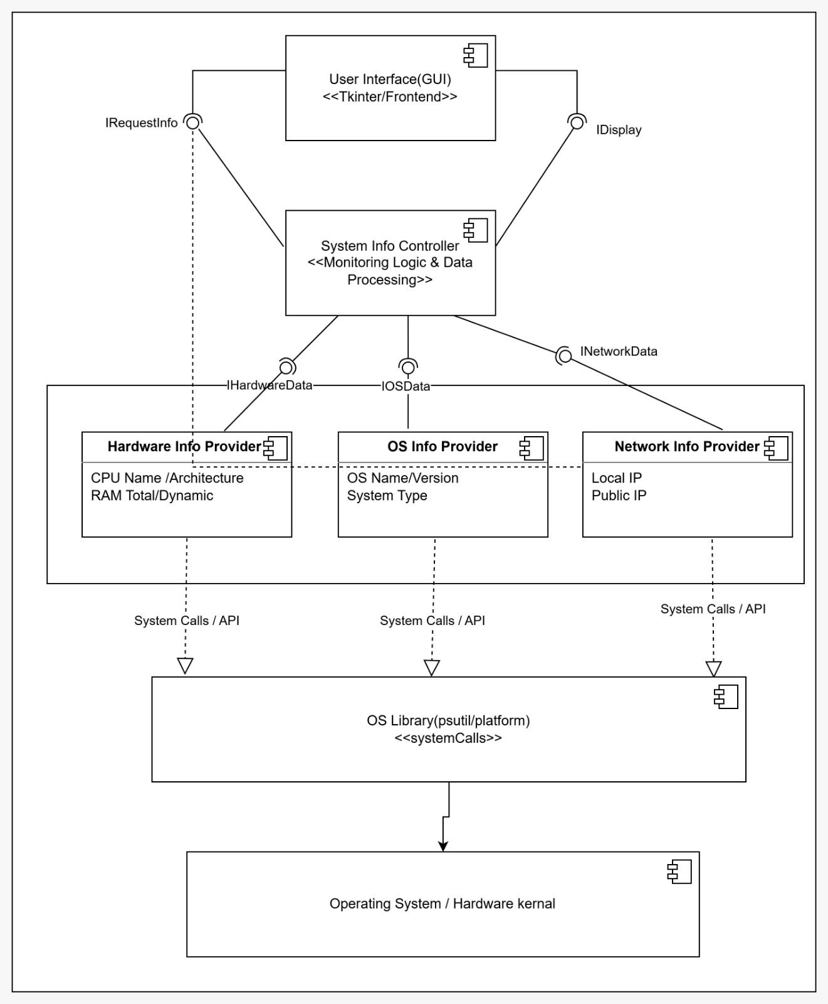
Figure 3.1

Component Diagram of the System Information Monitoring Tool
The system follows a modular Layered Component Architecture to ensure clean data flow and separation of logic.

Module Explanations
* User Interface (GUI):
This frontend component, developed using the Tkinter framework, provides the visual buttons and labels for user interaction. It handles input requests via the IRequestInfo interface and displays retrieved data through the IDisplay interface.
* System Info Controller:
Acting as the "Monitoring Logic & Data Processing" hub, this central component manages the communication between the UI and the data providers. It translates user actions into specific data requests and routes the returned information back to the GUI.
* Hardware Info Provider:
A specialized component responsible for communicating with system libraries to fetch hardware-level data, specifically CPU details (Name/Architecture) and RAM totals (Dynamic/Total).
* OS Info Provider:
This module focuses on retrieving software-related specifications, including the host machine's Operating System name, version details, and the system type.
* Network Info Provider:
This component manages all network-related data retrieval, specifically identifying the local network IP and the public IP address for the host system.
* OS Library (psutil / platform):
A middleware layer that uses standard Python libraries to execute systemCalls. It serves as the bridge between high-level application logic and the low-level operating system APIs.
* Operating System / Hardware Kernel:
The base layer of the architecture where the actual machine and kernel environment reside. It is the ultimate source of raw data accessed via system calls.

5. Input & Output Requirements
* Input Requirements:
User inputs are initiated through clicks on the GUI buttons to request specific system data modules. No manual typing of parameters is required as the system fetches data automatically.
* Output Requirements:
The system displays results as organized, structured text on the GUI, including specific labels for CPU, RAM, OS, and Network details.

6. Assumptions & Constraints
* Assumptions:
It is assumed that the host operating system is responsive to library calls and all button-click inputs are handled correctly by the controller.
* Constraints:
The application relies on the presence of the Python environment and specific libraries like psutil to interact with the host kernel. The document must be clear and professional.

